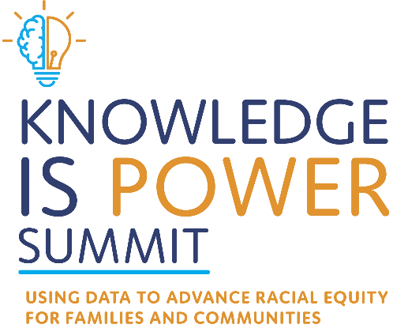
Action Plan Template
May 23rd-24th 2022

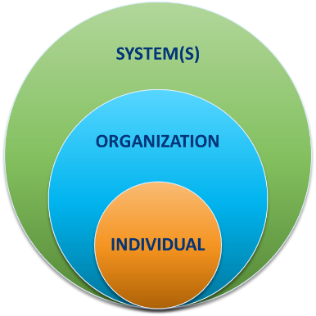
This template is designed to help you capture ideas and commitments for taking action at the individual, organizational, and systems level.
There is space for you to capture your ideas and commitments from each day of the Knowledge is Power Summit. You can use this document throughout the convening – and afterwards – to take what you learn and apply it. You will also find additional space on subsequent pages to take notes throughout the Summit for each key topic area.

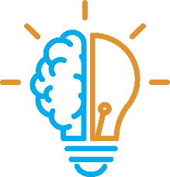
Knowledge is Power Summit Day 1

Individual Actions and Commitments
Click or tap here to enter text.

Organizational Level Actions and Commitments
Click or tap here to enter text.

Systems Level Actions and Commitments
Click or tap here to enter text.

Knowledge is Power Summit Day 2

Individual Actions and Commitments

Organizational Level Actions and Commitments
Click or tap here to enter text.

Systems Level Actions and Commitments
Click or tap here to enter text.


Day 1 Notes
Who are our families? Where are our families from?
Click or tap here to enter text.



How does mandated reporting impact our families?
Click or tap here to enter text.


How do maltreatment allegations impact our families?
Click or tap here to enter text.

Day 2 Notes

How does general neglect impact our families?
Click or tap here to enter text.


What services do our families receive?
Click or tap here to enter text.

