COMPONENT BASED FINITE ELEMENT METHOD
In the following unit, we will shortly introduce the elementary background of the Component-Based Finite Element Method (CBFEM) – the theory behind applications like IDEA StatiCa Connection, HILTI PROFIS Engineering, Advance Design Connection and others.
Design codes, e.g. EN1993-1-8, and also technical literature offer engineering solution methods. Their general feature is derivation for typical structural shapes and simple loadings. The method of components is used very often.
Component method (CM) solves the joint as a system of interconnected items – components. The corresponding model is built per each joint type to be able to determine forces and stresses in each component.
As can be seen in the following picture, each component is checked separately using corresponding formulas. As the proper model must be created for each joint type, the method usage has limits when solving joints of general shapes and general loads.
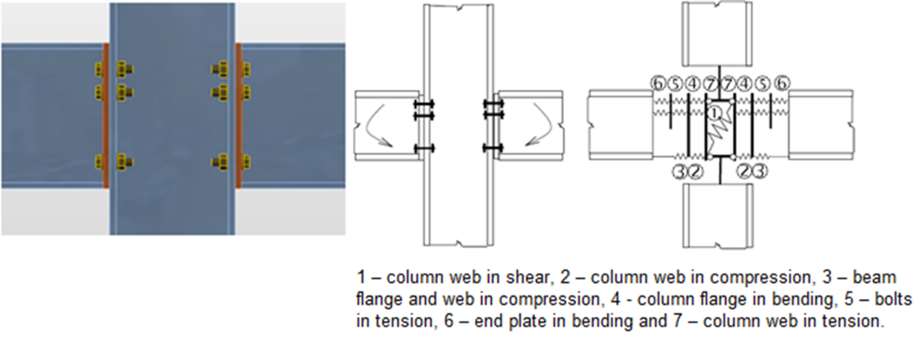
Figure 0.1. The components of a joint with bolted end plates modeled by springs.
Therefore, IDEA StatiCa together with a project team of Czech Technical University in Prague and Brno University of Technology developed a new method for advanced design of steel structural joints.
The new Component Based Finite Element Model (CBFEM) method is:
- General enough to be usable for most of joints, footings and details in engineering practice.
- Simple and fast enough in daily practice to provide results in a time comparable to current methods and tools.
- Comprehensive enough to provide structural engineer clear information about joint behavior, stress, strain and reserves of individual components and about overall safety and reliability.
The CBFEM method is based on the idea that the most of the verified and very useful parts of CM should be kept. The weak point of CM – its generality when analyzing stresses of individual components – was replaced by modeling and analysis using Finite Element Method (FEM).

CBFEM COMPONENTS
FEM is a general method commonly used for structural analysis. Usage of FEM for modeling of joints of any shapes seems to be ideal (Virdi, 1999). The elastic-plastic analysis is required, as the steel ordinarily yields in the structure. In fact, the results of the linear analysis are useless for joint design.
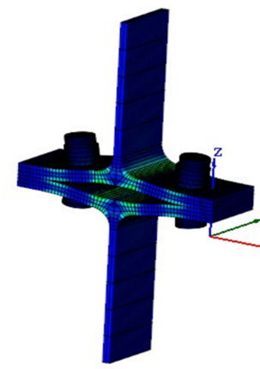
Figure 0.2. FEM model of a joint for research. It uses spatial 3D elements for both plates and bolts.
Both webs and flanges of connected members are modeled using shell elements in CBFEM model for which the known and verified solution is available.
The fasteners – bolts and welds – are the most difficult in the point of view of the analysis model. Modeling of such elements in general FEM programs is difficult because the programs do not offer required properties. Thus, special FEM components had to be developed to model the welds and bolts behaviour in a joint.
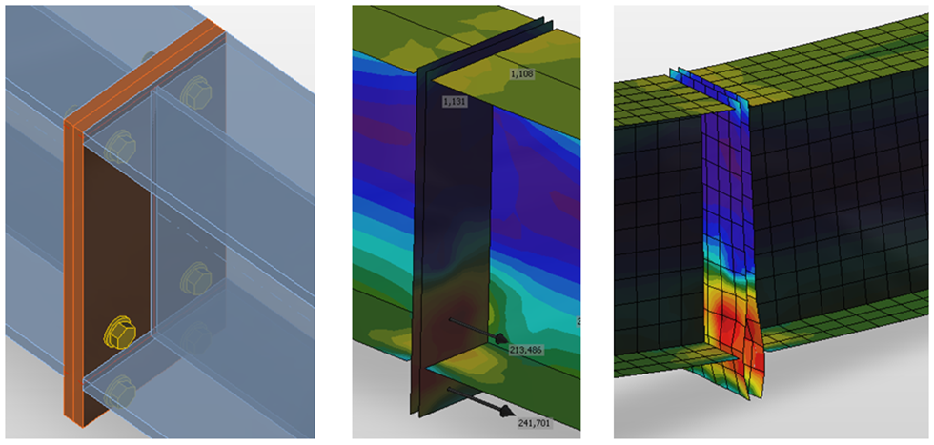
Figure 0.3. CBFEM model of bolted connection by end plates.
Joints of members are modeled as massless points when analyzing steel frame or girder structure. The resultant of forces from all members in the joint is zero – the whole joint is in equilibrium.
The real shape of a joint is not known in the structural model. The engineer only defines whether the joint is assumed to be rigid or hinged.
It is necessary to create the trustworthy model of joint, which respect the real state, to design the joint properly. The ends of members with the length of a 2–3 multiple of maximal cross-section height are used in the CBFEM method. These segments are modeled using shell elements.
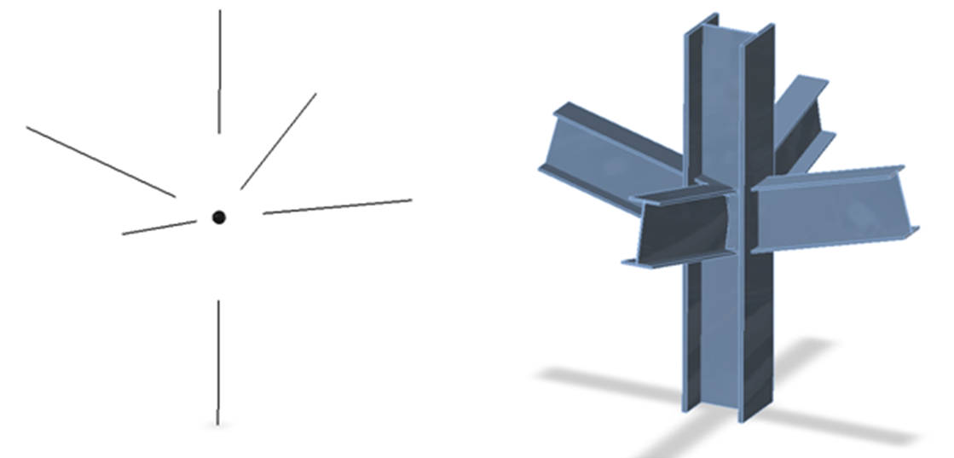
Figure 0.4. A theoretical (massless) joint and a real shape of the joint without modified member ends.
For better precision of CBFEM model, the end forces on 1D members are applied as loads on the segment ends. Sextuplets of forces from the theoretical joint are transferred to the end of segment – the values of forces are kept, but the moments are modified by the actions of forces on corresponding arms.

CBFEM ANALYSIS
The newly developed method (CBFEM – Component Based Finite Element Model) enables fast analysis of joints of several shapes and configurations. The model consists of members, to which the load is applied, and manufacturing operations (including stiffening members), which serve to connect members to each other. The analyzed FEM model is generated automatically. The designer does not create the FEM model, he creates the joint using manufacturing operations.

Material and plate model. FINITE ELEMENT MESH

MATERIAL MODEL
The plates in IDEA StatiCa Connection are modelled with elastic-plastic material with a nominal yielding plateau slope according to EN1993-1-5, Par. C.6, (2), tan⁻¹(E/1000). The material behaviour is based on von Mises yield criterion. It is assumed to be elastic before reaching the design yield strength,f_{yd}.
The ultimate limit state criterion for regions not susceptible to buckling is reaching the limiting value of the principal membrane strain. The value of 5% is recommended (e.g. EN1993-1-5, App. C, Par. C.8, Note 1).
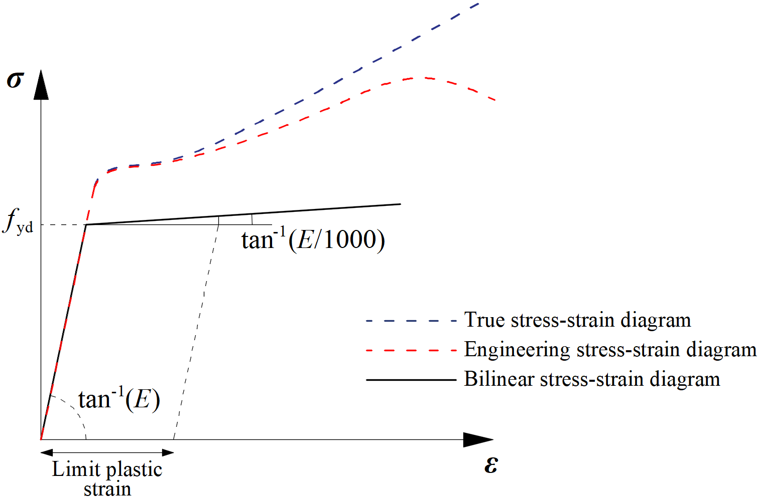
Figure 0.5. Material diagrams of steel in numerical models.

PLATE MODEL AND MESH
Shell elements are recommended for modeling of plates in FEA of structural connection. 4-node quadrangle shell elements with nodes at its corners are applied. Six degrees of freedom are considered in each node: 3 translations (u_{x}, u_{y}, u_{z}) and 3 rotations (φ_{x}, φ_{y}, φ_{z}). Deformations of the element are divided into the membrane and the flexural components.
The shell is divided into five integration layers through thickness of the plate at each integration point and plastic behaviour is analyzed in each point.
Only the maximum stresses and strains of all layers are shown.
All plates of a beam cross-section have a common division into elements. The size of generated finite elements is limited. The minimal element size is set to 10 mm and the maximal element size to 50 mm (can be set in Code setup). Meshes on flanges and webs are independent of each other. The default number of finite elements is set to 8 elements per cross-section height as shown in the following figure. The user can modify the default values in Code setup.
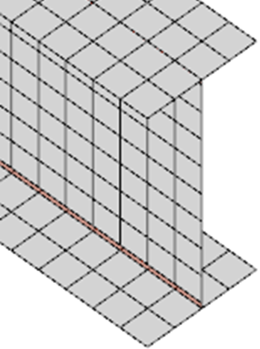
Figure 0.6. The mesh on a beam with constraints between the web and the flange plate.

CONTACTS
If penetration of a node into an opposite contact surface is detected, penalty stiffness is added between the node and the opposite plate. The contact between the plates has a major impact on the redistribution of forces in connection.
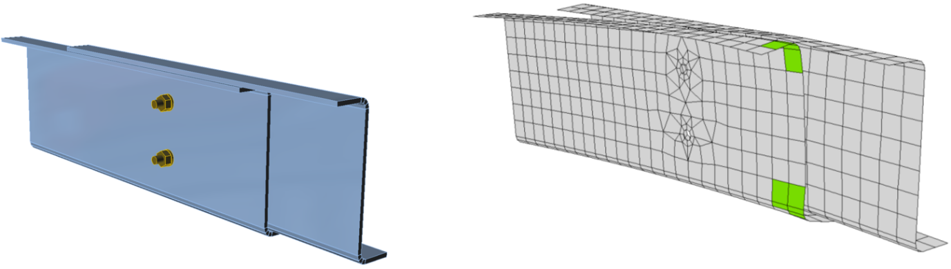
Figure 0.7. An example of separation of plates in contact between the web and flanges of two overlapped Z sections purlins.
It is possible to add contact between:
- two surfaces,
- two edges,
- edge and surface.
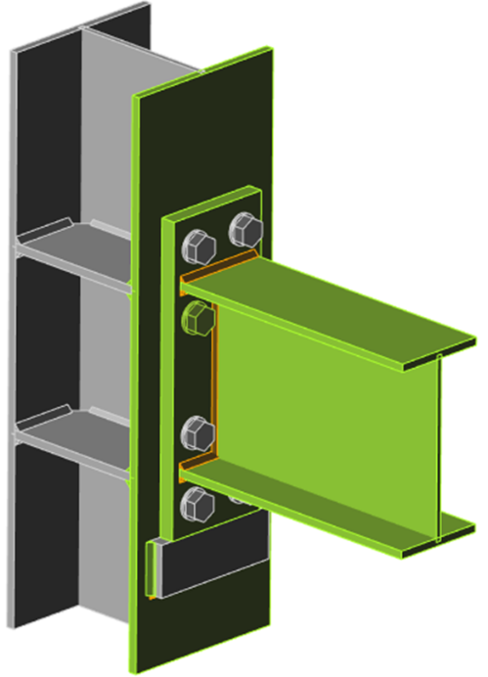
Figure 0.8. An example of edge to edge contact between the seat and the end plate.
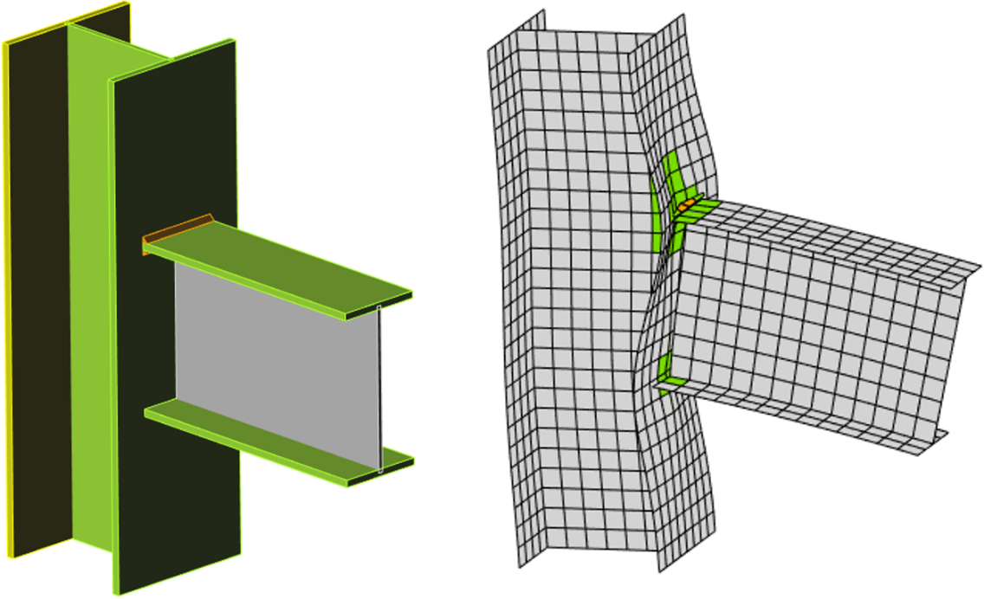
Figure 0.9. An example of edge to surface contact between the lower flange of the beam and the column flange.

Welds, BOLTS, ANCHORS AND CONCRETE BLOCK

WELDS
The load is transmitted through force-deformation constraints based on the Lagrangian formulation to opposite plate. The connection is called multi-point constraint (MPC) and relates the finite element nodes of one plate edge to another. The finite element nodes are not connected directly.
The advantage of this approach is the ability to connect meshes with different densities. The constraint allows to model midline surface of the connected plates with the offset, which respects the real weld configuration and throat thickness.

PLASTIC STRESS REDISTRIBUTION IN WELDS
The model with only multi-point constraints does not respect the stiffness of the weld and the stress distribution is conservative. Stress peaks which appear at the end of plate edges, in corners and rounding, govern the resistance along the whole length of the weld. To eliminate the effect, a special element with nonlinear (elastoplastic) material is added between the plates. The stress peaks are redistributed along the longer part of the weld length.
Elastoplastic model of welds gives real values of stress and there is no need to average or interpolate the stress. Calculated values at the most stressed weld element are used directly for checks of weld component. This way, there is no need to reduce the resistance of multi-oriented welds, welds to unstiffened flanges or long welds.
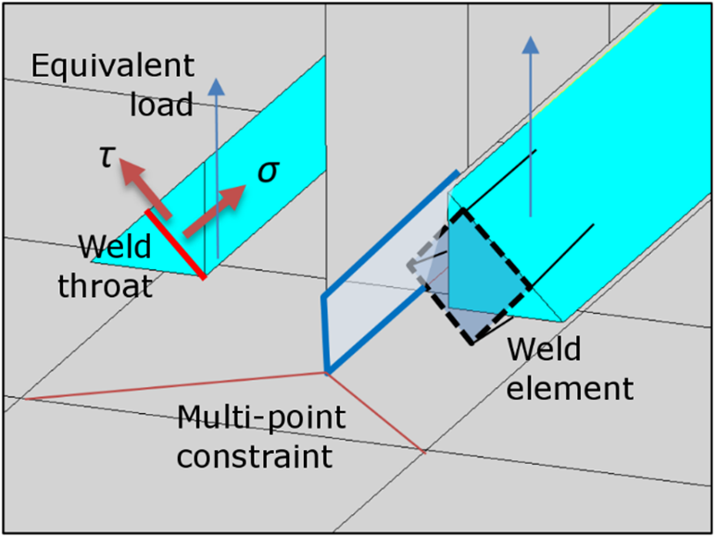
Figure 0.10. Constraint between weld element and mesh nodes.

STANDARD BOLTS
In the Component Based Finite Element Method (CBFEM), bolt with its behaviour in tension, shear and bearing is the component described by the dependent nonlinear springs. The bolt in tension is described by spring with its axial initial stiffness, design resistance, initialization of yielding and deformation capacity. For initialization of yielding and deformation capacity, it is assumed that plastic deformation occurs in the threaded part of the bolt shank only.
The tensile force is transmitted to the plates by interpolation links between the bolt shank and nodes in the plate. The transfer area corresponds to the mean value of the bolt shank and the circle inscribed in the hexagon of the bolt head.
Deformation capacity is considered according to Wald et al. (2002) as:
$$δ_{pl}=3 δ_{el}$$
Initialization of yielding is expected at (see the following figure): $F_{ini}=2 / 3 F_{b,Rd}$
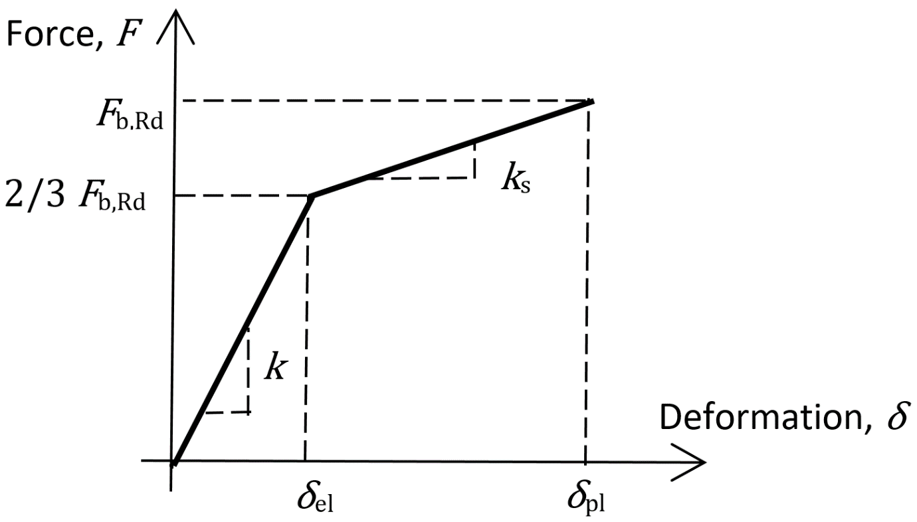
Figure 0.11. Force-deformation diagram for bearing of the plate.
Only the compression force is transferred from the bolt shank to the plate in the bolt hole. It is modeled by interpolation links between the shank nodes and holes edge nodes. The deformation stiffness of the shell element modeling the plates distributes the forces between the bolts and simulates the adequate bearing of the plate.
Bolt holes are considered as standard (default) or slotted (can be set in plate editor). Bolts in standard holes can transfer shear force in all directions, bolts in slotted holes have one direction excluded and can move in this selected direction freely.
Interaction of the axial and the shear force can be introduced directly in the analysis model. Distribution of forces reflects the reality better (see enclosed diagram). Bolts with a high tensile force take less shear force and vice versa.

PRELOADED BOLTS
Preloaded bolts are used in cases when minimization of deformation is needed. The tension model of a bolt is the same as for standard bolts. The shear force is not transferred via bearing but via friction between gripped plates.
The design slip resistance of a preloaded bolt is affected by an applied tensile force.
IDEA StatiCa Connection checks the pre-slipping limit state of preloaded bolts. If there is a slipping effect, bolts do not satisfy the check. Then the post-slipping limit state should be checked as a standard bearing check of bolts where bolt holes are loaded in bearing and bolts in shear.
The user can decide which limit state will be checked. Either it is resistance to major slip or post-slipping state in shear of bolts. Both checks on one bolt are not combined in one solution. It is assumed that bolt has a standard behavior after a major slip and can be checked by the standard bearing procedure.
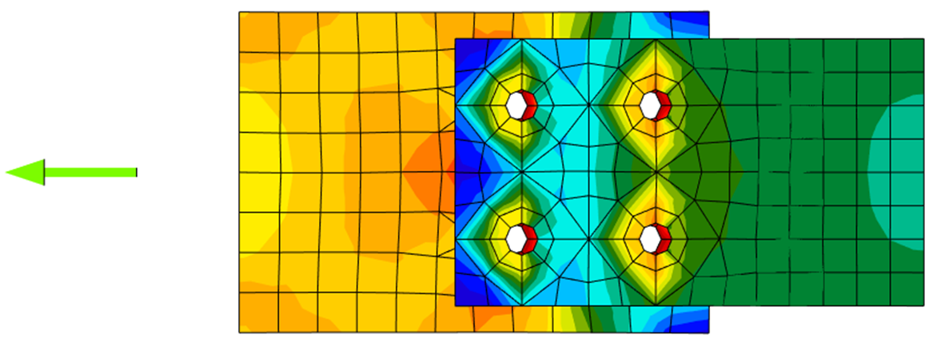
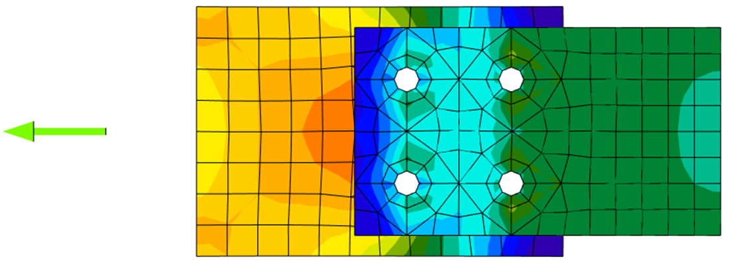
Figure 0.12. Stress distribution in standard and slip-resistant shear bolt connection.

ANCHOR BOLTS
The anchor bolt is modeled with the similar procedures as the structural bolts. The bolt is fixed on one side to the concrete block. Its length, L_{b}, used for bolt stiffness calculation is taken as a sum of half of the nut thickness, washer thickness, t_{w}, base plate thickness, t_{bp}, grout or gap thickness, t_{g}, and the free length embedded in concrete which is expected as 8d where d is a bolt diameter.
This factor, 8, is in accordance with the Component Method (EN1993-1-8). The free length embedded in concrete can be modified in Code setup.
The stiffness in tension is calculated as $k=E∙A_{s} / L_{b}$. The load–deformation diagram of the anchor bolt is shown in the following figure.
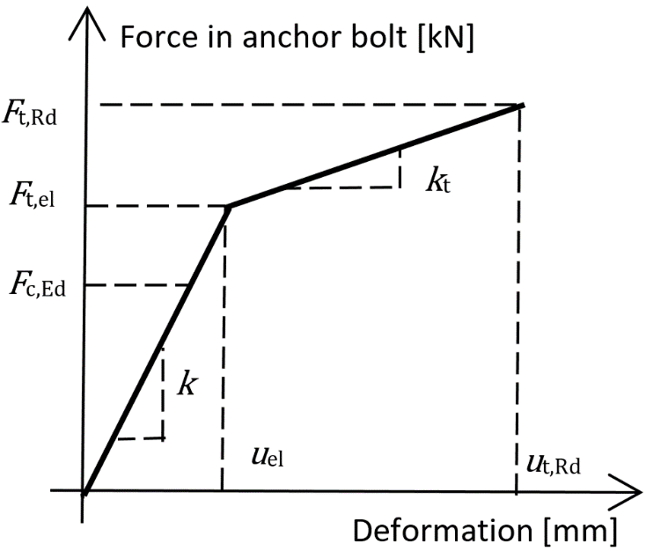
$$F_{t,el}=\frac{F_{t,Rd}}{c_{1}c_{2}-c_{1}+1}$$
$$k_{t}=c_{1}k ; c_{1}=\frac{R_{m}-R_{e}}{\left(\frac{1}{4}A-\frac{R_{e}}{E}\right)E}$$
$$u_{el}=\frac{F_{t,el}}{k} ; u_{t,Rd}=c_{2}u_{el} ; c_{2}=\frac{AE}{4R_{e}}$$
Figure 0.13. Load–deformation diagram of the anchor bolt.
where:
- A – elongation.
- E – Young's modulus of elasticity.
- F_{t,Rd} – steel tensile resistance of anchor.
- R_{m} – ultimate (tensile) strength.
- R_{e} – yield strength.
The stiffness of the anchor bolt in shear is taken as the stiffness of the structural bolt in shear.

ANCHOR BOLTS WITH STAND-OFF
Anchors with stand-off can be checked as a construction stage before the column base is grouted or as a permanent state. Anchor with stand-off is designed as a bar element loaded by shear force, bending moment and compressive or tensile force. These internal forces are determined by finite element model. The anchor is fixed on both sides, one side is 0.5×d below the concrete level, the other side is in the middle of the thickness of the plate. The buckling length is conservatively assumed as twice the length of the bar element. Plastic section modulus is used. The forces in anchor with stand-off are determined using finite element analysis. Bending moment is dependent on the stiffness ratio of anchors and base plate.
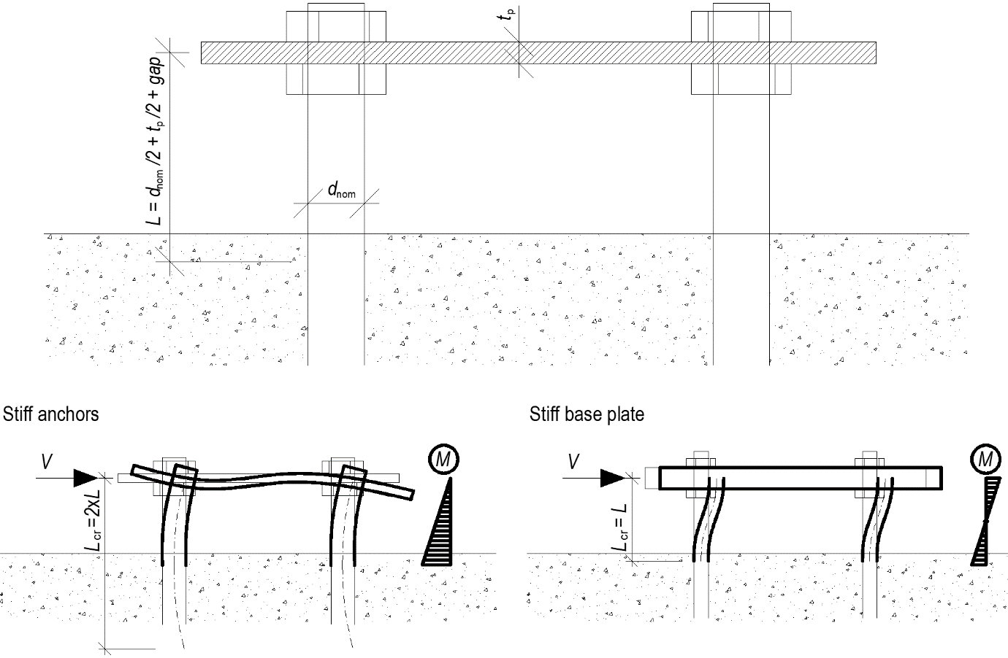
Figure 0.14. Anchors with stand-off – determination of lever arm and buckling lengths; stiff anchors are safe assumption.

CONCRETE BLOCK

DESIGN MODEL
In CBFEM, it is convenient to simplify the concrete block as 2D contact elements. The connection between the concrete and the base plate resists in compression only. Compression is transferred via Winkler-Pasternak subsoil model which represents deformations of the concrete block. The tension force between the base plate and concrete block is carried by the anchor bolts.
The stiffness of the concrete block may be predicted for the design of column bases as an elastic hemisphere. A Winkler-Pasternak subsoil model is commonly used for a simplified calculation of foundations.
The shear load at the base plate can be transferred by three means:
- Friction.
- Shear lug.
- Anchors.
User can choose the mean by editing the base plate operation. No combination of means is allowed in the software, however, EN 1993-1-8 – Cl. 6.2.2 and Fib 58 – Chapter 4.2 allows for the combination of shear transfer by anchors and friction under certain conditions. In general, it is conservative to neglect friction in the design of the anchorage, although it may in some cases lead to an underestimation of concrete cracking at the serviceability level. As a rule, frictional resistance should be neglected if:
- the thickness of the grout layer exceeds one-half the anchor diameter,
- the anchorage capacity is governed by a near-edge condition,
- the anchorage is intended to resist earthquake loads.
The combination with shear lug should never be allowed due to the deformation compatibility.
The resistance of bolts in shear is assessed analytically. Friction and shear lug are modeled as a full single point constraint in the plane of the base plate – concrete contact.

TRANSFER OF SHEAR LOAD BY FRICTION
The shear resistance is equal to the resistance safety factor multiplied by friction coefficient editable in Code setup and compressive load. The compressive load includes all forces, e.g. in case of a column base loaded by compressive force and bending moment, the compressive load used for frictional shear resistance might be higher than the applied compressive force.

TRANSFER OF SHEAR LOAD BY SHEAR LUG
The shear lug is simulated as a stub encased in concrete under the base plate. The shear load is estimated to be transferred by uniform load distribution acting on the whole portion of the shear lug embedded in concrete block, i.e. all nodes of the shear lug below the concrete surface are uniformly load. The portion of the shear lug above concrete surface in grout is not assumed to transfer the shear load.
Be aware that the lever arm between the applied shear load (at the base plate) and the shear resistance (half height of the shear lug embedded in concrete) causes a bending moment which must be transferred by compressive force in concrete and tensile forces in anchors.
The shear lug consists of shell finite elements and is checked as regular plates. Also, the welds of the shear lug to the base plate are checked using standard procedures in IDEA StatiCa Connection. Manual calculation usually assumes beam theory for the shear lug, although it is not accurate because the length to width ratio is very small for shear lug. Therefore, there might be significant difference between IDEA StatiCa Connection and manual calculation.

TRANSFER OF SHEAR LOAD BY ANCHORS
The shear resistance is determined by the shear resistance of anchors. The steel resistance of anchors has elastoplastic load-deformation curve, but the concrete failure modes are considered as perfectly brittle.

